**County of Santa Cruz**

**Department of Community Development and Infrastructure**

**701 Ocean Street, Fourth Floor, Santa Cruz, CA 95060**

**Planning (831) 454-2580 Public Works (831) 454-2160**

**https://cdi.santacruzcountyca.gov/**

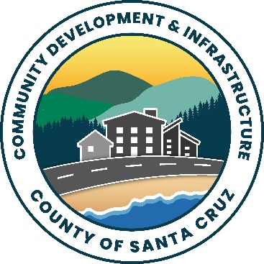

**NOTICE OF ENVIRONMENTAL REVIEW PERIOD**

APPLICANT:  **Delta Group Engineering**

APPLICATION NO.: 221049

PARCEL NUMBER (APN): 080-062-02

The Environmental Coordinator has reviewed the Initial Study for your application and made the following preliminary determination:

x Negative Declaration

(Your project will not have a significant impact on the environment.)

**X** Mitigations will be attached to the Negative Declaration.

No mitigations will be attached.

Environmental Impact Report

(Your project may have a significant effect on the environment. An EIR must be prepared to address the potential impacts.)

As part of the environmental review process required by the California Environmen­tal Quality Act (CEQA), this is your opportunity to respond to the preliminary determination before it is finalized. Please contact Matt Johnston, Environmental Coordinator at Matt.johnston@santacruzcounty.us, if you wish to comment on the preliminary determination. Written comments will be received until 5:00 p.m. on the last day of the review period.

To apply to the Department of Fish and Wildlife for a “letter of no effect” you may contact them directly at the Yountville office at (707) 944-5500. A “letter of no effect” will only be considered for projects that do not involve any physical change to the environment.

Review Period Ends: 2/05/2025

**Staff Planner: Sheila McDaniel**

Phone**: (831)454-2255**

Date: 1/9/2025